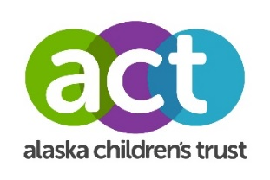
GRANT AMENDMENT REQUEST FORM

Organization:

Project Title:

Name:

Date of request:

Address:

Email:

Phone:

Grant Dates: (mm/dd/yyyy) to (mm/dd/yyyy)

Grant Amount Awarded:

How much of the Grant Award has already been utilized?

Please answer the following questions on a separate document (attach to this request form):
- Outline the need for the grant amendment.
- Will the funds continue to be used for the original project? If no, outline the new project and how the funds will be utilized
- Outline the new timeline of completing the project, if different from the original.

I certify that to the best of my knowledge that all disbursements and obligations have been/will be made in accordance with the purposes and conditions of this grant.

Authorized Representative Signature Date

Name & Title

ALASKA CHILDREN’S TRUST USE ONLY

ACT Approving Official’s Signature Date

